#include<stdio.h>

int main(){
for(int i=1;i<6;i++){
for(int j=1;j<i+1;j++){
printf("%d \t",j);
}
printf("\n");
}
return 0;
}
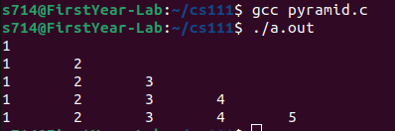

nclude<stdio.h>

int main(){
int a,b;
int gcd=0;
printf("enter the two numbers \n");
scanf("%d %d", &a,&b);
for(int i=1;i<a+b;i++){
if(a>b){
if(a%i==0 && b%i==0 && i!=a){
gcd=i;
}
}
else{
if(a%i==0 && b%i==0 && i!=b){
gcd=i;
}
}
}
int lcm;
lcm=a*b/gcd;
printf("the lcm and gcd of the two numbers is %d and %d respectively \n",lcm,gcd);
}
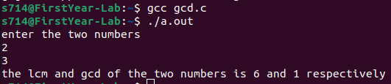

include<stdio.h>
#include<math.h>

int main(){
int x,n;
printf("enter x,n respecitvely: \n");
scanf("%d %d",&x,&n);
int result=0;
int fact=1;
for(int i=0;i<n+1;i++){
for(int j=1;j<i+1;j++){
fact=fact*j;
}
result+=pow(x,i)/fact;
}
printf("%d \n",result);
}
